CLARIFICATION OF THE PROJECT AND BILL OF MATERIALS
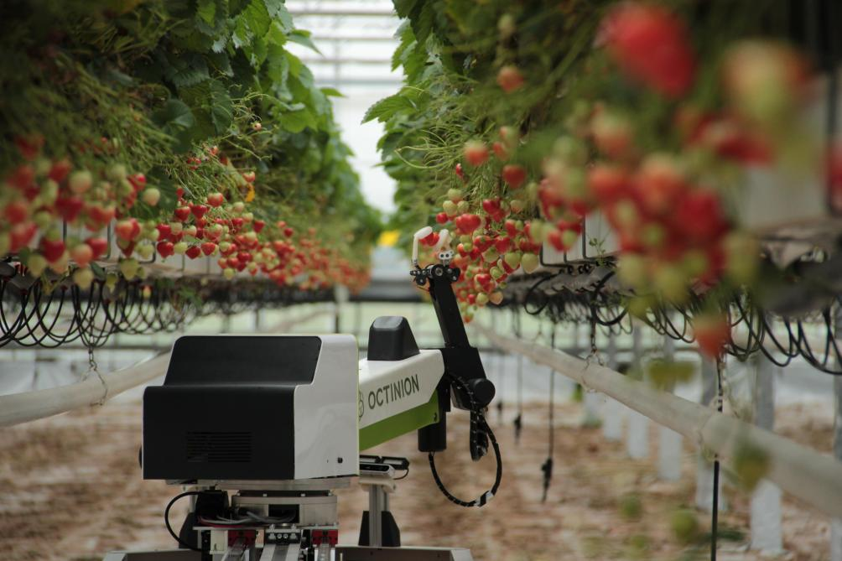

Summary
I— The goal of the project
II — Break down the project: the different parts of the project
III — Project requirements: required and available materials
IV — Document and deliverable requirements

I— The goal of the project
The project is to Design and Implementation of Crop Recognition and Precision Picking System in
Agricultural Scenarios Based on Mobile Picking Robot

II — Break down the subject: the different parts of the project
1. Design a system allowing the autonomous navigation of the robot in the picking path.
- Explanation:
The goal is to make the robot move automatically in a field.
- Tools and stages:
- Laser radar
- IMU module
- Develop a SLAM mapping algorithm under ROS to construct a 10m x 5m simulated agricultural scene map.
NB: mark crop-planting rows and irrigation-facility obstacle areas.
- Combined with point 3, the “zero spin radius” characteristic of the Mecanum wheel (spin radius ≤0 mm).
- Design an A* path planning algorithm suitable for the crop row spacing.
- Realize the robot’s autonomous cruise along the planting row.
- Ultrasonic obstacle avoidance
- precise docking at picking points.
- Adapting to the narrow working space of agricultural scenarios such as greenhouses.

2. Development of Crop Recognition and Maturity Judgment Module
- Explanation:
The goal is to develop a module that allows the system to recognize a crop and its maturity.
- Tools and indication:
- Collect data on simulated crops commonly used in competitions (such as strawberries and tomatoes).
- Construct a crop image dataset with "unripe-ripe-overripe" labels.
- Use YOLOv5s/MobileNet lightweight deep learning models to develop crop recognition and maturity classification algorithms.
- Improve agricultural scene adaptability through transfer learning (pre-trained based on COCO dataset), output 2D coordinates of RGB images and 3D depth positions of mature crops, ensuring recognition accuracy ≥92% and single-frame processing time ≤0.3s.
- Combined with the 60° field of view of the camera module.

3. Precision Picking Control of Robotic Arm and Adaptive Gripper
- Explanation:
Allow a robot hand to pick a crop with an adaptive gripper
- Tools and stages:
- Complete the hand-eye calibration of the 3-4 DOF robot arm based on ROS hand-eye calibration tools.
- Establish a coordinate mapping model of "depth camera-robotic arm base coordinate-gripper end".
- Convert the 3D position of crops into robotic arm motion commands.
- Develop picking trajectory planning logic through Python programming interface.
- Control the robotic arm to act according to the process of "approaching crops
→ adaptive gripper opening → precise clamping (automatic force adjustment according to crop diameter) → lifting off the plant → transferring to the storage box".
- Optimize the gripper control strategy: adjust the clamping force through pressure sensor feedback for different crops such as strawberries (diameter 2-4cm) and tomatoes (4- 6cm) to avoid crop damage or falling.

4. System Integration and Performance Optimization
- Explanation:
The goal is to add some features to the robot: voice, battery and stability monitory …
- Tools and indication:
- Integrate the voice control function (based on TTL serial voice module, 5V power supply), support voice commands such as "start picking", "pause picking", and "switch crop type" (Response time ≤1s) to adapt to the convenient operation needs of agricultural scenarios.
- Increase the picking volume per unit time to ≥15 pieces/minute.
- Build a simulated agricultural scene test platform
- Monitor the stability of the robotic arm motor PWM signal (ripple ≤100mV), and system power consumption (full-load cruise ≤15W) with oscilloscopes and multimeters.
- Optimize the lithium battery power supply strategy (working time ≥4h)
- Test the system stability at 0~40℃ and 5%-80% humidity to ensure trouble-free operation ≥8h.

III — Required materials and available materials.
Required materials
Thread 1: Design a system allowing the autonomous navigation of robot in the picking path.
1- LiDAR
2- IMU module
3- Enable to perform SLAM algorithm
4- Enable to Design an A* path planning algorithm
5- Mobile robot
6- Ultrasonic sensor
7-Encoders
8-ROS/Ubuntu 20.04

Thread 2: Development of Crop Recognition and Maturity Judgment Module.
1-RGB-D Depth Camera
2-Raspberry Pi 4B
3-YOLOv5s / MobileNetz
4-Dataset (on strawberries and tomatoes)
5-OpenCV 4.8
6-PyTorch 2.0

Thread 3: Precision Picking Control of Robotic Arm and Adaptive Gripper.
1-Hiwonder Robotic (Arm with 3-4 DOF)
2-Bus Servos
3-Adaptive Gripper
4-Arm Camera
5-Pressure sensor
6-Storage box
7- A box for keeping the crop
8- Python

Thread 4: System Integration and Performance Optimization.
1-LiPo Battery
2-USB Audio Module
3-Speakers
4-BMS monitoring
5-Multi-threading (ROS)
6-Oscilloscope and Multimeter

Available materials
Materials | LiDAR | IMU module | Mobile robot | Ultrasonic sensor | Encoders | ROS/Ubuntu 20.04 | RGB-D Depth Camera
Status | built-in on the LIMO | built-in on the LIMO | (car)  LIMO | built-in on the LIMO | built-in on the LIMO | Pre-installed | built-in on the LIMO

Raspberry Pi 4B | Bus Servos | Adaptive Gripper | Arm Camera | Pressure sensor | ROS/Ubuntu 20.04 | Storage box
built-in on the robot arm | Mounted on the arm | Mounted on the arm | Mounted on the arm | To verify | To install | To prepare

LiPo Battery | USB Audio Module | Speakers | BMS monitoring | Multi-threading (ROS) | Oscilloscope and Multimeter
built-in on the robot arm | Aivalable | Available | To configure | To develop | Lab equipement

Robot arm with 4 DOF
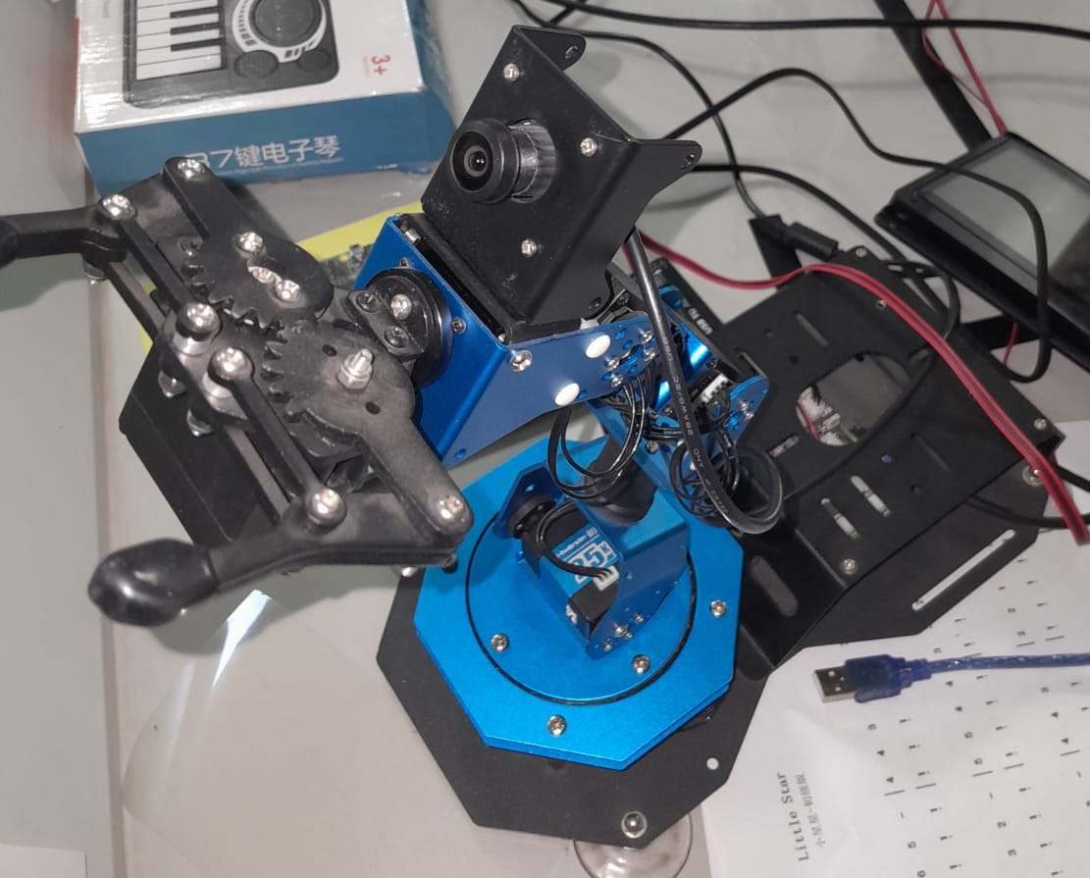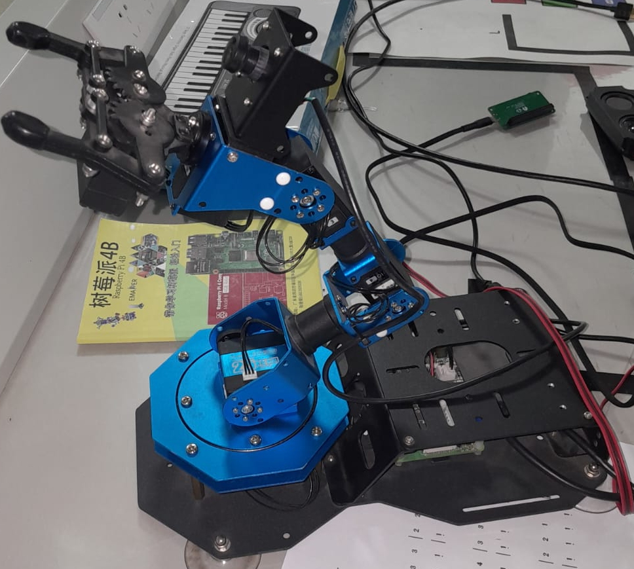

Car LIMO
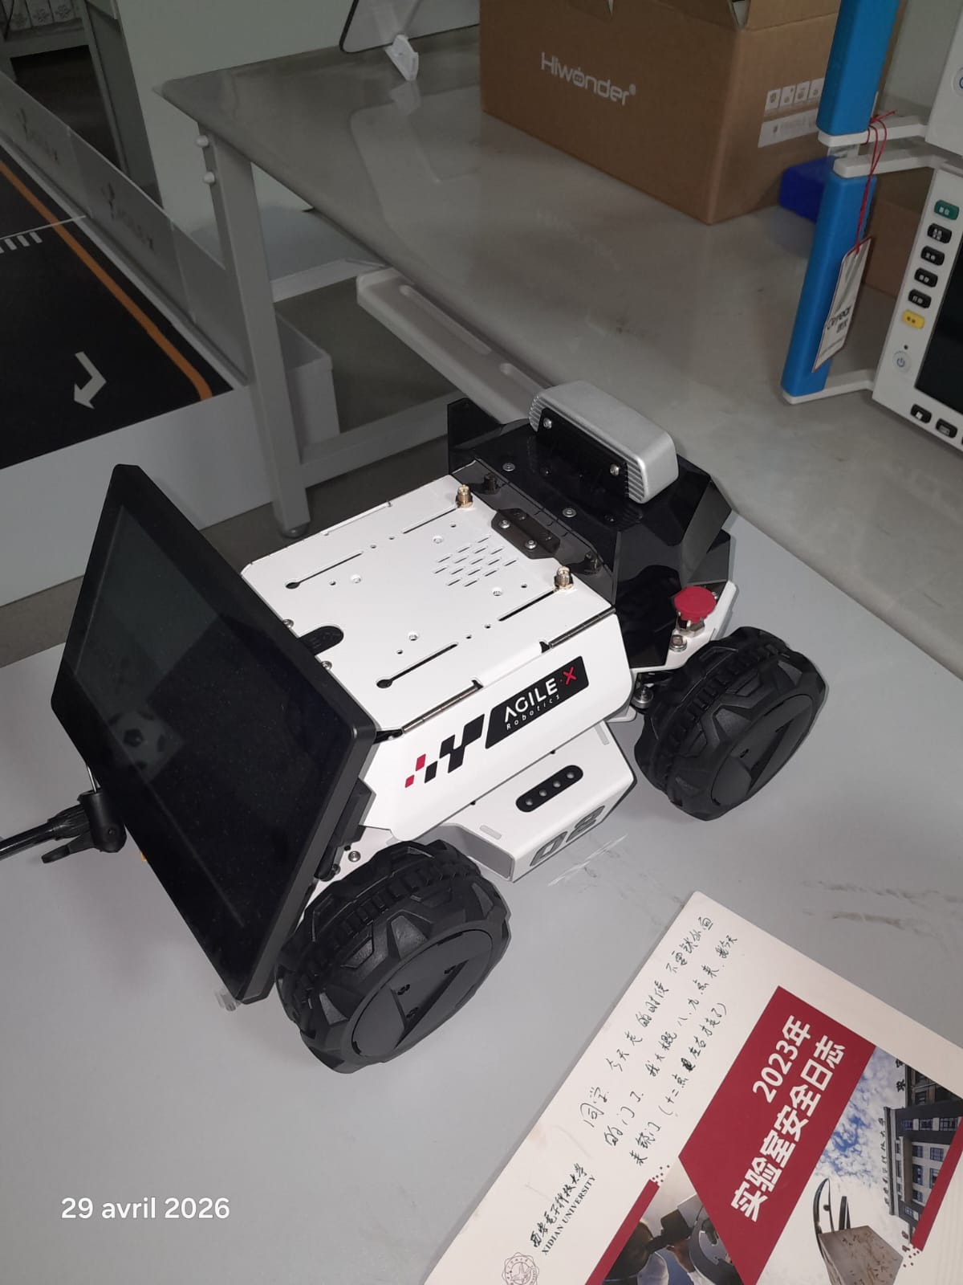

IV — Document and DELIVERABLE requirements

1. Design Specification:
Which shall include:
① Requirement Analysis (interpretation of competition rules, agricultural scenario requirements,
functional/performance indicators).
② Hardware Selection (models, parameters and selection basis of each module, with attached equipment compatibility test report).
③Algorithm Design (flowcharts of navigation/recognition/picking modules, derivation of
core formulas, code logic).
④ Test Report (functional test data, environmental
adaptability test results, competition simulation test analysis). References shall be no
less than 16 articles (including literatures related to agricultural robots and machine
vision in the past 3 years).

2. Runnable Source Code:
Stored by module classification (navigation module,
recognition module, picking control module, interaction module), with a code
comment rate of ≥65%. It shall include function descriptions, parameter meanings
and key logic explanations; provide an environment configuration document
specifying the operating system (Ubuntu 20.04/Windows 10), dependency library
versions (ROS Noetic, PyTorch 2.0, OpenCV 4.8), hardware driver installation steps,
and model training & operation commands; attach pre-trained model files (in .pt
format) and test datasets (including crop images, scenario maps, and annotation
files).

3. System Operation Manual:
Oriented to competition operators and maintenance personnel. Its content shall include:
① Equipment, Assembly Guide (connection steps and schematic diagrams of chassis, robotic arm,
and sensors).
② Competition Operation Process (system startup, map construction,
picking task initiation, emergency fault handling).
③ Parameter Debugging Skills (Methods for adjusting recognition thresholds, gripper force, and navigation speed).
④ Troubleshooting for Common Problems (solutions to motor failures, low
recognition accuracy, robotic arm jamming, etc.). It shall combine pictures and texts,
and attach a link to the competition scenario operation video (≥8 minutes) and
precautions for competition adaptation.

